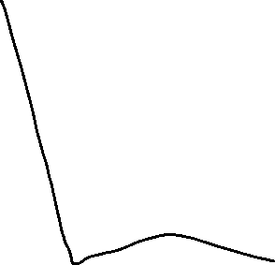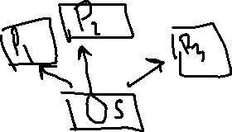

1)Threads use shared memory area.

2)Threads -> faster content switching.

3)A thread is light weight, whereas a process is heavy weight.

